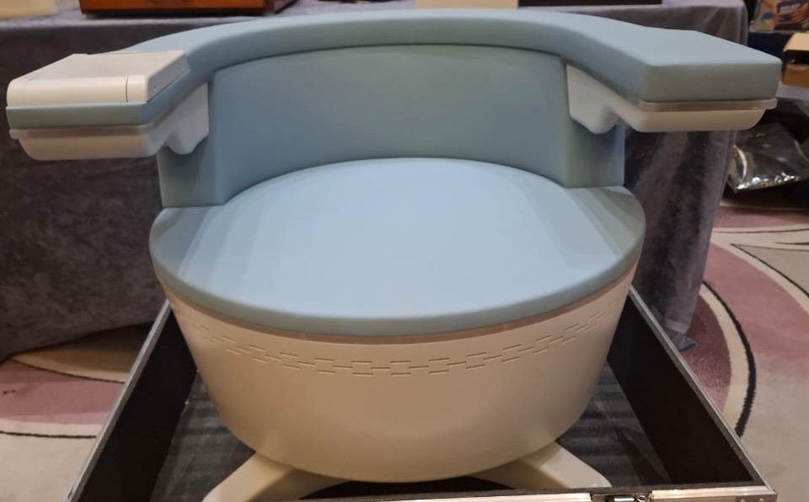

EMS PELVICE FLOOR CHAIR
An electromagnetic pelvic therapy chair, often used for pelvic floor muscle stimulation—commonly in treatments for urinary incontinence, pelvic pain, or postnatal rehabilitation.
It is a non-invasive device designed to strengthen pelvic floor muscles and treat urinary incontinence.

Specifications :
Technology: High-Intensity Focused Electromagnetic (HIFEM)
Power Consumption: 2.3 KVA
Pulse Width: 300 μs
Frequency Range: 1–160 Hz
Electromagnetic Field Intensity: Adjustable up to 7 Tesla
Voltage: AC 100V–220V, 50/60 Hz
Dimensions: Approximately 76×70×65.5 cm
Weight: Net weight ~45 kg; Gross weight ~62 kg
Treatment Duration: 30 minutes per session
Recommended Protocol: 6–8 sessions, typically twice a week
Muscle Contractions per Session: Up to 12,000
Penetration Depth: Up to 10 cm
Certifications: CE, ISO medical device standards

A randomized controlled trial demonstrated that electromagnetic stimulation therapy significantly improved pelvic floor muscle strength in postpartum women with stress urinary incontinence. The EMS group showed greater muscle strength gains compared to the Kegel exercise group (16.5 vs. 8.0 cmH₂O, p = 0.006). Both groups experienced significant improvements in urinary distress scores and pad test results.
Another study reported that 58% of patients experienced objective improvement in urinary incontinence after undergoing functional magnetic stimulation therapy using a magnetic chair. Additionally, 71% reported subjective improvement, indicating the treatment's effectiveness and patient satisfaction.

Benefits :
- Non-Invasive Treatment: Patients remain fully clothed during sessions.
- No Downtime: Immediate return to daily activities post-treatment.
- High Patient Satisfaction: Significant improvements in muscle tone and pelvic health.
- Versatile Applications: Suitable for treating stress, urge, and mixed urinary incontinence, as well as for postpartum recovery.
- Quick Sessions: Each session lasts approximately 28–30 minutes, fitting conveniently into busy schedules

